RESEARCH
Please cite this paper as: Tam, A. Kohn, G. Correlation between pH studies and oesophageal multichannel intralumminal impedance in the evaluation of typical gastro-oesophageal reflux. AMJ 2023;16(5): 642-646.
https://doi.org/10.21767/AMJ.2023.3956
Corresponding Author:
Name: Adrian Tam
Address: U1215. 38 Bank Street. South Melbourne. Victoria, Australia. 3205
Email address: Adrian.j.tam@gmail.com
ABSTRACT
Background
In additional to accepted 24-hour ambulatory pH studies, multichannel intraluminal impedance testing is thought to improve pre-operative assessment and aid diagnosis of atypical reflux-related symptoms. While a measure of concordance between the results of these two tests is expected, as both aim to detect the same phenomenon of reflux, the actual concordance between pH study results and impedance values in typical reflux-related symptoms is unknown.
Aims
To assess the correlation between pH studies and impedance testing in patients with typical reflux symptoms.
Methods
100 consecutive patients undergoing oesophageal physiology testing for typical reflux symptoms of heartburn or regurgitation were reviewed. All patients were required to cease acid suppressant and promotility agents at least 7 days prior. Pre-study localisation of the lower oesophageal sphincter was made manometrically. All patients were encouraged to ingest a refluxogenic challenge meal during the study period. Reflux episodes noted during meal times were excluded. Pearson’s correlation co-efficient was calculated for catheter-based 24-hour pH results compared to 8-channel intraluminal oesophageal impedance values. Common descriptors of association between the two tests’ results were calculated.
Results
Correlation between Demeester composite score and total number of impedance detected reflux events was r = 0.4015. The positive predictive value of impedance for Demeester score > 14.72 was 83%. The sensitivity of abnormal impedance testing for detecting abnormal Demeester score was 15.63% and the specificity was 94.4%.
Conclusion
There is poor correlation between 24-hour pH results and impedance scores. Therefore, the utility of impedance assessment for typical reflux symptoms is poor.
Key Words
PH study, intraluminal impedance, gastro-oesophageal reflux, oesophageal physiology.

What this study adds:
1. What is known about this subject?
To bolster the relatively new body of evidence advocating against reliance on impedance studies in the decision-making process regarding operative vs non-operative management of GORD.
2. What new information is offered in this study?
Lack of concordance between new impedance studies versus accepted pH studies in an Australian population, which by Euclid’s axiom suggest inferiority of multi-lumen impedance studies.
3. What are the implications for research, policy, or practice?
Potential decrease the number of futile operations undertaken for GORD based on results of multi-channel intraluminal impedance studies.
Background
Gastro-esophageal Reflux Disease (GERD) is a condition that develops as a result of reflux of stomach contents causing troublesome symptoms and/or complications¹. Its wide prevalence, particularly in Western and Asian populations, carries with it a significant economic burden, highlighting the importance of accurate diagnosis². Symptoms of GERD are grouped as typical or atypical symptoms.³ Both, however, can mimic other esophageal and extra-esophageal diseases making symptom analysis alone for diagnosis unreliable^{3,4}. As such, objective evaluation of patients with pH monitoring, manometry, and endoscopy is highly recommended, and indeed considered mandatory by many⁵.
Traditionally, a DeMeester Composite Score (DMS) can be calculated for the diagnosis of GERD by recording the total number of reflux events, the number of reflux events longer than 5 minutes, the total percent time of pH below 4, the percent time of pH below 4 in the upright position, the percent time of pH below 4 in the supine position and the longest reflux episode⁶. More recently, Acid Exposure Time (AET) alone, as defined as acid exposure of greater than 6 per cent of time monitored through 24-h pH monitoring, has been increasingly used to define GERD. Interestingly, there is a trend whereby surgeons prefer DMS, while gastroenterologists have been more recently relying on the use of AET ⁷. It is important to note that there is criticism regarding both, and that neither has been shown to be superior over the other.
In addition to acidic reflux, it is thought that non- or weakly-acidic reflux can also produce GERD symptoms.⁸ This is detectable by measuring changes in the impedance between electrodes placed on multichannel intraluminal impedance (MII) catheter. Many reflux episodes have been found by MII to be weakly acidic in nature, and these are not reliably identified by standard pH testing ^{9,10}. Weakly acidic reflux has been implicated as a major cause for refractory GERD in patients that fail pharmacological therapy.
As such, there have been multiple studies that suggest the use of MII testing in combination with 24-hour pH monitoring provides better sensitivity in diagnosis and prediction of surgical outcomes in those with atypical symptoms when compared to 24-hour pH studies alone ^{11,12}. Interestingly, there are also studies suggesting that parameters derived from standalone MII have poor predictive value ^{13,14}. However, the role of MII testing in those with strictly typical GERD is less well studied. Use the of MII catheters increases significantly the cost of a study over solely pH-metry – if it does not add much to the diagnosis, then this should be seen as an unnecessary cost.
If the current hypotheses that:
- a positive pH study is a predictor of good ant reflux surgery outcome in patients with typical GERD symptoms, and
- the addition of MII improves sensitivity of GERD detection,
Then it is logical to expect there to be a reasonably strong correlation between pH studies and MII in reflux patients, even though the tests measure different factors. Using different techniques, both tests are essentially aiming to detect GERD attributable to an impaired anti-reflux mechanism of the lower esophagus. Although it is true that not all refluxate is acidic, all acidic reflux is still refluxate. Accordingly, there should be some correlation between the two studies.
This study aims to confirm the expected correlation between 24-hour pH studies and MII testing in order to assess the utility of MII testing in patients with typical symptoms of GERD.

Method
One hundred (100) consecutive patients with typical symptoms of GERD underwent esophageal physiology testing including 24-hour pH testing and MII testing. All patients undergoing the study were required to cease their acid suppression medication at least 7 days prior to testing.
Pre-study localization of the lower esophageal sphincter (LES) was obtained by using manometry. A combined MII-pH catheter probe was calibrated prior to study using buffered solution and the probe was placed with the pH electrode 5cm above the LES. Six sensors located at 3, 5, 7, 9, 15 and 17cm from the LES were used to measure impedance. Patients were encouraged to ingest refluxogenic food over a 24-hour period. Reflux episodes during meal times were excluded. Patients were asked to press a button whenever they experienced a reflux event, and to simultaneously record the nature of the event (chest pain, heartburn etc) and whether they were upright or supine.
A DMS was generated for each patient pH test using the parameters described earlier. Values greater than 14.72 were considered to represent abnormally elevated distal esophageal acid exposure.
If MII detected retrograde flow of fluid, then this was determined to be a reflux event. It was considered acidic if the pH of the refluxate was below 4, or considered a weakly acidic or non-acid reflux episode if the pH was above 4.
Results
Sixty-one of the one-hundred patients were female (mean age 54, range 17-84 years). 43 patients were documented to have been on acid suppressant medications prior to the study. Of these, one patient’s cessation date was not recorded and three patients had ceased medication within seven days prior to the study. These patients were included in the study.
Sixty-four out of one hundred patients were identified as having GERD by positive pH test (Demeester composite score >14.72).
MII testing was positive in only ten out of the sixty-four patient with pH test positive.
The positive predictive value of MII testing for an abnormal pH test was 83.3% and the negative predictive value was 38.6% (Table 1). Of note, MII testing was positive in two patients with a negative pH test. Both of these patients were female, one of whom experienced heartburn, and the other regurgitation.
The symptom Index (SI) for each symptom associated with acid and weak acid reflux is summarized in Table 2. An SI value of greater than 0.5 is considered clinically significant ¹⁵. only heartburn and regurgitation reached clinically significant SI levels while no symptoms showed any relevant SI with regard to weak acid reflux episodes.
The Symptoms Association Probability (SAP) was best for heartburn and acidic reflux, whereas all symptoms demonstrated poor SAP in relation to weakly acidic reflux Table 3.
Chi-square analysis was used to examine the association between positive pH testing with positive MII testing. The Chi-square test was 2.2122, with a p-value of 0.137 Table 4, indicating no significant correlation between the two tests.
Similarly, Pearson’s correlation coefficient was used to compare raw DeMeester scores with MII detected reflux events showing a lack of linear correlation with an r=0.4015 Figure 1.
Discussion
For patients with typical symptoms of GERD, a positive DeMeester score (corresponding to an abnormal 24-hour pH study) has been shown to correlate with a favourable outcome after surgery. Thus, ambulatory pH study is a useful tool for pre-operative assessment.
The results of our study suggest a poor correlation between positive 24-hour pH studies and positive MII testing in the evaluation of GERD for patients with typical symptoms of reflux, as supported by a non-significant Chi-Square test evaluating the relationship between the two.
MII testing has both a poor sensitivity and negative predictive value for diagnosing GERD in the setting of patients experiencing typical symptoms. Only 0.08 % of reflux episodes in the study (85 of 1109) were found to be weakly acidic. This would imply that patients with typical reflux symptoms do not have significant weakly acid or non-acid reflux events. Data summaries in table 2 suggests each symptom of heartburn, chest pain, regurgitation and cough were more strongly associated with acid reflux (identified with pH testing) than weak acid reflux (detected with MII).
The combined use of 24-hour pH studies and MII for patients with atypical symptoms of reflux has been investigated with numerous studies, which have implicated weak or non-acid reflux as a major factor for persistent reflux with patients on acid suppression medication. Many patients after combined pH-MII testing have been selected for fundoplication surgery, and have had successful outcomes post-operatively suggesting that combined pH and MII testing is a useful predictor of successful candidates for fundoplication in those with atypical symptoms of GERD. However, the role of MII testing alone in those with typical symptoms of GERD is not well understood in current literature.¹⁰ Frazzoni et al. found that patients with refractory GERD , who responded well to surgical intervention, had predominantly weakly acidic reflux, defined as refluxate with pH 4-7.¹⁶ Although these would not have been picked up by traditional pH testing, either through isolated AET or DMS scoring, these would in theory have been detected by MII, thus leading to the theory at first glance that pH-MII testing can be beneficial. However, Frazzoni’s study also found no symptom association in non-acidic/alkaline reflux, and in fact, an increase in non-acidic reflux after fundoplication.¹⁶ These non- GERD contributing episodes of reflux would also be detected by MII, which would explain the perceived increased sensitivity of MII, but would also reveal a large source of false positives detected. We believe this explains the poor predictive value of MII, as well as the poor correlation between MII and pH-monitoring seen in our study.
Data from this study suggests that MII testing has poor sensitivity and negative predictive value for diagnosing GERD in patients with typical symptoms. Thus its usefulness for typical reflux symptoms is low.
Our study is not without limitations. Some patients included in analysis remained on acid suppression therapy. Various studies have suggested an improvement in detection of reflux whilst others have suggested the contrary ^{17,18}. As an observational study, lack of patient randomisation with gender (61 % female), age matching and other confounders, may create bias impacting on external validity of results.
Conclusion
In conclusion, we propose MII has poor utility as an additional tool to evaluate non-acid suppressed patients with typical reflux symptoms. Though further studies are required to validate our findings, this may indicate that pH testing alone is being more cost effective for such patients.
References
- Vakil N, Van Zanten SV, Kahrilas P, et al. The Montreal definition and classification of gastroesophageal reflux disease: a global, evidence-based consensus paper. Z. fur Gastroenterol. 2007;45(11):1125-40. Doi: https://doi.org/10.1055/s-2007-963633
- Namasivayam V, Arora AS, Murray JA. Weakly acidic reflux. Diseases of the Esophagus. 2011;24(1):56-62.
Doi: https://doi.org/10.1111/j.1442-2050.2010.01100.x
- Weigt J, Monkemüller K, Peitz U, et al. Multichannel intraluminal impedance and pH-metry for investigation of symptomatic gastroesophageal reflux disease. Dig Dis. 2007;25(3):179-82.
Doi: https://doi.org/10.1159/000103881
- Gyawali CP, Kahrilas PJ, Savarino E, et al. Modern diagnosis of GERD: the Lyon Consensus. Gut. 2018;67(7):1351-62.
Doi: http://dx.doi.org/10.1136/gutjnl-2017-314722
- Andolfi C, Vigneswaran Y, Kavitt RT, et al. Laparoscopic antireflux surgery: Importance of patient's selection and preoperative workup. J. Laparoendosc Adv Surg. Tech. 2017;27(2):101-5. Doi: https://doi.org/10.1089/lap.2016.0322
- Johnson LF, Demeester TR. Twenty-four-hour pH monitoring of the distal esophagus. Am J Gastroenterol. 1974;62(4).
- Neto RM, Herbella FA, Schlottmann F, et al. Does DeMeester score still define GERD?. Diseases of the Esophagus. 2019;32(5):118. Doi: https://doi.org/10.1093/dote/doy118
- Sifrim D, Zerbib F. Diagnosis and management of patients with reflux symptoms refractory to proton pump inhibitors. Gut. 2012;61(9):1340-54. Doi: http://dx.doi.org/10.1136/gutjnl-2011-301897
- Gruebel C, Linke G, Tutuian R, et al. Prospective study examining the impact of multichannel intraluminal impedance on antireflux surgery. Surg Endosc. 2008;22:1241-7. Doi: https://doi.org/10.1007/s00464-007-9599-8
- Gawron AJ, Hirano I. Advances in diagnostic testing for gastroesophageal reflux disease. World J Gastroenterol. 2010;16(30):3750.
Doi: https://doi.org/10.3748%2Fwjg.v16.i30.3750
- Del Genio G, Tolone S, Del Genio F, et al. Prospective assessment of patient selection for antireflux surgery by combined multichannel intraluminal impedance pH monitoring. J Gastrointest Surg. 2008;12:1491-6. Doi: https://doi.org/10.1007/s11605-008-0583-y
- Patel A, Sayuk GS, Kushnir VM, et al. GERD phenotypes from pH‐impedance monitoring predict symptomatic outcomes on prospective evaluation. Neurogastroenterol Motil.2016;28(4):513-21. Doi: https://doi.org/10.1111/nmo.12745
- Patel A, Sayuk GS, Gyawali CP. Acid-based parameters on pH-impedance testing predict symptom improvement with medical management better than impedance parameters.Am J Gastroenterol. 2014;109(6):836. Doi: https://doi.org/10.1038%2Fajg.2014.63
- Zerbib F, Belhocine K, Simon M, et al. Clinical, but not oesophageal pH-impedance, profiles predict response to proton pump inhibitors in gastro-oesophageal reflux disease. Gut. 2012;61(4):501-6. Doi: https://gut.bmj.com/content/61/4/501.short
- Vaezi MF. Use of symptom indices in the management of GERD. Gastroenterol Hepatol. 2012;8(3):185.
- Frazzoni M, Conigliaro R, Melotti G. Reflux parameters as modified by laparoscopic fundoplication in 40 patients with heartburn/regurgitation persisting despite PPI therapy: a study using impedance-pH monitoring. Dig Dis Sci. 2011;56:1099-106. Doi: https://doi.org/10.1007/s10620-010-1381-4
- Bredenoord AJ, Weusten BL, Timmer R, et al. Addition of esophageal impedance monitoring to pH monitoring increases the yield of symptom association analysis in patients off PPI therapy. Official journal of the American College of Gastroenterology| ACG. 2006;101(3):453-9.
- Hershcovici T, Fass R. An algorithm for diagnosis and treatment of refractory GERD. Best Pract. Res. Clin. Gastroenterol. 2010;24(6):923-36. Doi: https://doi.org/10.1016/j.bpg.2010.10.004

ACKNOWLEDGEMENTS

PEER REVIEW
Not commissioned. Externally peer reviewed.

CONFLICTS OF INTEREST
The authors declare that they have no competing interests.

FUNDING
The authors did not receive financial support for the research, authorship and publication of this article. The authors are not recipients of a research scholarship and this manuscript is not based on previous communication to a meeting or society.

ETHICS COMMITTEE APPROVAL
[N/A]

Figures and Tables
Table 1 Correlation between pH and MII testing in GORD diagnosis
 | Positive pH test | Negative pH test | Total no. of patients
Positive MII | 10 | 2 | 12
Negative MII | 54 | 34 | 88
Total no. of patients | 64 | 36 | 100
Table 2 Symptom Indices with strong and weak acid reflux
Symptom | Acid Reflux SI | Weak Acid Reflux SI
Heartburn | 0.58 | 0.03
Chest Pain | 0.37 | 0
Regurgitation | 0.53 | 0.05
Cough | 0.41 | 0.06
Table 3 Symptom association probability with acid reflux and weak acid reflux (SAP range 0-100)
Symptom | No. of Patients | Mean SAP (Acid reflux)/% | Mean SAP (weak acid reflux)/%
Heartburn | 55 | 74.2 | 26.0
Chest pain | 6 | 45.1 | 0
Regurgitation | 43 | 61.4 | 26.4
Cough | 37 | 64.2 | 23.2
Table 4 Chi-Square analysis of positive pH testing with positive MII testing
 | Positive pH test | Negative pH test | no. of patients
Positive MII | 10 (7.68) [0.7] | 2 (4.32) [1.25] | 12
Negative MII | 54 (56.32) [0.1] | 34 (31.68) [0.17] | 88
No. of patients | 64 | 36 | 100

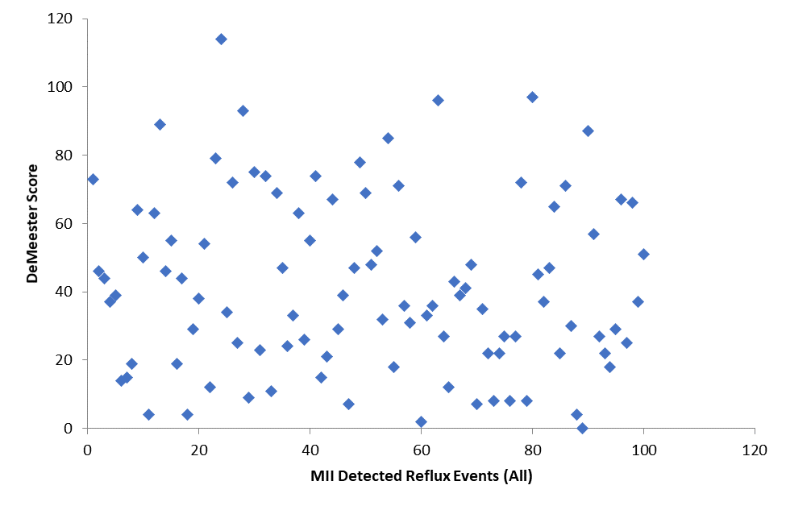
Figure 1: Correlation between DeMeester scores and impedance detected reflux events

Received: 24-May-2023, Manuscript No. AMJ-23-3956; Editor assigned: 27-May-2023, PreQC No. AMJ-23-3956(PQ); Reviewed: 11-Jun-2023, QC No. AMJ-23-3956; Revised: 17-Jun-2023, Manuscript No. AMJ-23-3956(R); Published: 24-Jun-2023

