RESEARCH
Please cite this paper as: Parvez F, Spoorthy SM. Suicide in health care workers during the covid-19 pandemic in India. AMJ 2022;15(11):517-.
https://doi.org/10.21767/AMJ.2022.3914
Corresponding Author:
Fariha Parvez
department of Psychiatry,
Jawaharalnehru medical college, sawangiwardha
India
Farihaparvez20@gmail.com
ABSTRACT
Background
As we all know, the globe, including India, is dealing with the COVID-19 pandemic. It has caused a slew of psychological issues for millions of people. Healthcare workers remain the most vulnerable group only next to the general population for psychological impact due to COVID-19. Though there is an array of psychological issues suicidal behavior as a result of COVID-19 remains an important aspect of identification and management.
Objective
To assess the prevalence of suicidal behavior in frontline workers during the COVID-19 pandemic.
Methods
The literature search was conducted using a combination of medical subject headings (Mesh) and free text terms. From December 2019 to August 2021, a search was done in all databases with no restriction of language. As a part of the primary screening, the research studies which involved the assessment of depression, anxiety, stress, sleep disturbances, traumatic stress, and psychological impact were encompassed. Regardless of the scale used for assessment, studies describing any of the aforementioned results were assessed. Later on, only studies that assessed suicidality were further screened and included in the review.
Conclusion
Healthcare workers were at high risk of suicidal behavior due to the COVID-19 pandemic. Those with pre-existing psychiatric illness were at higher risk of developing suicidal ideations
Key Words
Health care workers, Frontline workers, covid 19 Pandemic, Suicide, Stress, Anxiety, Depression, Insomnia

Introduction
The COVID-19 pandemic has posed many challenges to mankind at large and the healthcare system in particular. Healthcare systems across the world had to handle the overwhelming burden of the pandemic. Healthcare workers (HCWs) are playing a primary role in the management of this crisis all over the world. Though the impact of COVID-19 on the world remained more or less similar, there is a huge difference in its impact on the healthcare system depending upon the country. Low and middle-income countries like India have to face additional challenges like severe shortage of health professionals, scarcity of beds, scarcity of oxygen, and poor healthcare infrastructure. Before complete recovery from the first wave, the country (India) remained one of the worst affected ones by the second wave. The impact of the second wave on the country's health system is far away from its actual capacity ^{1,2}.
Amidst all these adversities, HCWs remained the backbone of managing the situation and bringing the situation under control. They played critical roles in the diagnosis and treatment and handled their responsibility to treat despite increased personal risks. Health workers are experiencing high work volume, personal risk, and pressure to meet high demands for healthcare ^{3,4}.
While COVID-19, 2nd wave, frontline workers often encountered difficulties as a result of an increased workload, a demanding work schedule, and a higher risk of being exposed to positive patients.
The most vulnerable category, the infection victims, are afraid of disease and its outcome, being isolated from their families, losing jobs, being discriminated against, and being vilified by society as per a recent review, healthcare workers have high psychological burden due to the pandemic only next to the general population⁵.

Multiple factors were responsible for the COVID-19 hazarda on mental health. First, poor healthcare infrastructure, unavailability of oxygen, beds, medicines, and overburdened doctors created uncertainty everywhere. The role of media in repeatedly displaying the negative side of the disease like death, agony, and mishaps in the system has further worsened the degree of stress in the public. In people who were affected by the illness, one of the main reasons for worsening/improvement was mainly their awareness about the disease, the degree of fear of death will power. A dearth of vaccinations has again created uncertainty, fear, and anxiety among the general public.
Although the spread and fatality were higher in the second wave compared to the first wave, still a majority developed only mild-moderate illness. Unaware of this fact, due to the stigma, guilt/self-blame some patients have committed or attempted suicide after acquiring the illness. But there is no way we the doctors of the country can focus on the mental health of every patient. Irrespective of the branch of post-graduation, doctors from all fields have come up to handle the health emergency. Despite this only the physical health of the patients admitted is being taken care of. Instances of suicide due to the pandemic were also seen by doctors themselves.
Anxiety, fear, stress, depression, workload, insomnia, psychological distress, misbehavior of patients and their relatives, exposure to COVID, and restriction to meet their own family all have a cumulative effect on mental health. Several studies were conducted since the onset of the pandemic in India which evaluated the psychological impact of the pandemic on HCWs. Mostly the focus of these studies remained the assessment of depression, anxiety, and insomnia^{5,6}. Assessment of suicidal behaviour among healthcare workers was carried out only by a few studies.
There is a greater awareness of the need to safeguard our hospital workers from disposure to COVID-19 and its repercussions, and latest healthcare system expectation may have an impact on healthcare workers' physical as well as psychological well-being during the COVID-19 pandemic.
We aimed to conduct a review of studies that have evaluated suicidality in healthcare workers due to the pandemic in India.

Objective
To portray an overview of suicidal behavior during the COVID-19 among hcws in states of India.
We conducted a systematic review of observational studies via an electronic web search of PubMed between December 2019-August 2021. To publish our review, we adhered to the PRISMA criteria for systematic reviews integrating analyses. Figure 1 A highly hypoxic tumor microenvironment is a hallmark for human cancer including HCC, due to its rapid growth rate and surrounding fibrotic

The criterion for publications that will be reviewed
Type of studies
We included all the original research articles in the primary screening that investigated the psychological status & mental health of frontline workers in India while the epidemic. The original articles included in the screening were taken into account regardless of the form in which they were published. Original research published in the form of a Letter to the Editor/original research/correspondence was included for screening. Out of these studies, those that assessed suicidality in healthcare workers was finally examined as a secondary screening. No restriction was put on the type of study design, and the age group was assessed for inclusion in the review. We included studies regardless of where they were conducted or how they were interviewed (online/offline). There were full-text papers, abstracts, and preprints included, as well as case studies.
Type of participants
Healthcare workers were considered as the target participants for performing our review. Regardless of the line of employment, we incorporated studies that involved healthcare professionals: including medical professionals such as physicians, nurses, and paramedics⁷.
Type of outcome measure
As a part of the primary screening, the research studies which involved the assessment of, anxiety, stress, sleep disturbances, depression, stress after trauma, and psychological impact were incorporated. Regardless of the scale used for assessment, evaluation of these studies were done. Following the assessment, only those studies that assessed suicidality were considered reviewed. Hence, our outcome measure remained an assessment of suicidal behavior among healthcare workers.

Search strategy
Extensive electronic searches were performed using PubMed, MED-LINE, Chinese National Knowledge Infrastructure (CNKI), Cochrane library, Science Direct, and Google Scholar. Medical subject headings (Mesh) and free text keywords were combined to conduct the research. The research was conducted in all databases without regard to publication language from December 2019 to August 2021. To find any important articles to include it in this analysis, the reference lists of the primary retrieved papers were searched. we find some relevant studies from these sites and select some of them.

Selection of studies
The literature research was carried out by two independent investigators who examined the heading, summary, and important words. For relevant studies, full-text articles were collected. Two investigators independently screened the full article of the selected articles to choose the studies that met the inclusion criteria. During the selection process, any conflicts were handled by consensus or consulting with a third investigator. The third investigator likewise kept an eye on the quality of the selection procedure. Where ever necessary cross-references were thoroughly screened for eligibility and inclusion in the current review.
Out of 73 articles that were selected through initial identification, 44 were selected for primary screening procedures. 18 original research articles were excluded from primary screening as the study population was patients, other professionals, general population⁸. 11 articles were excluded as they were review articles/letters to the editor/commentaries on the topic. Out of the 44 eligible for primary screening, only 3 original research articles were eligible for final inclusion criteria. Rest were excluded as none of them assessed suicidal behavior/ideation as a primary/secondary outcome.
As mentioned in the Table 1 all the studies included as a part of the final review were observational cross-sectional studies. One of the three studies was conducted on COVID-19-infected healthcare personnel⁹, whereas the rest were conducted on HCWs working in COVID-19 centers. A study conducted by Parthasarathy et al, 2021 assessed the psychological impact of COVID-19 after conducting a workshop on mental well-being¹⁰. No structured assessment of suicide was conducted by any of the included studies. Studies conducted by Dabholkar, 2020 and Parthasarathy have used online questionnaires to assess suicidal ideation. Item-9 of PHQ was used as a measure of assessment of suicide by Grover 2021. The prevalence of suicidal behavior ranged between 7.5 per cent - 12.9 per cent among the health care workers. All of them showed findings suggestive of increased suicidal behaviour in HCWs after the pandemic whereas one study has shown that pre-existing psychiatric disorders increase the chances of suicidality in doctors and para-medics.

Discussion
While the pandemic of COVID-19, health workers were afflicted by significant levels of worry, stress, and despair, according to his research. This pandemic has impacted negatively on the population's mental and physical health, particularly among healthcare personnel, and demand for mental health services is on the rise. Healthcare workers themselves also have personal life along with their professional life.
The difficulty in balancing personal and professional lives, long working hours, inadequate personal protective equipment, shortage of staff, fear of being infected with the virus, and fear of spreading the virus in the family remain the main challenges for the health care workers. These take a toll on their mental health making them vulnerable to the development of depression, anxiety, stress, sleep disturbances, and suicidal behavior. Those working in the frontline are at higher risk of developing these psychiatric problems compared to their peers^{11,12}.
Despite the ongoing vaccination drive in the country with preference given to front-line workers early in the drive, a total of around 624 doctors have died due to Covid-19 in the second wave. Seeing their friends and colleagues die due to the disease can be traumatic and painful for others. What is of further concern is that no address of the mental health needs of the doctors is being done. The most effective output can only be possible if someone is physically and mentally sound.
COVID-19-related suicide rates are far higher than the national norm, indicating a serious need to address the issue. In the general population, during the first week after being diagnosed with COVID-19 and undergoing therapy in COVID-19 care, there is a higher risk of suicide. The two most prevalent methods were hanging and jumping.
This highlights the importance of doctors, public health officials, and administrators incorporating multilevel and inter-sectoral suicide prevention techniques throughout COVID-19 care^{13,14}.
The current review also highlighted the need for support structures and coping mechanisms to help healthcare employees cope with stress, anxiety, and depression. These strategies might be created to target female healthcare workers (HCWs) who have a chronic illness, a family member who has the condition, a history of psychiatric problems, interaction with verified COVID19 patients, or who lack social support. Furthermore, it is critical to take care of HCWs to improve their physical as well as mental health, that helps the conditions of medical services as a hcws during this pandemic^{15,16}.
There is an immense need to create interventions that not only strengthen HCW inside as well out of the hospitals while sticking to covid guidelines. In Wuhan, China, a virtual peer support group was launched that offered frontline healthcare workers and licensed mental health professionals social support, peaceful sleep and various techniques, and solving their problems. Similar to this, different social & ecological steps that are dependent on the identified factors of risk might be the focus of attention. For example, a University-based hospital finds out a layered opportunity to assist doctors and their teams by giving medical services and mental support at 3 socioecological levels that are :1- individual, 2- team, and 3-community.
Community includes stress and resilience town halls. a peer support system and mental support is included in team level. wellness checks and the health of doctors and their teams is included in individual level.
It has been demonstrated that receiving support from the organization helps preserve their mental health amid such outbreaks. As a result, the company has to make sure that its personnel is suitably supported. They should have a clear idea about their policy, strategy, proper planning, and everyday operational technique in place for their personnel. Employer institutions can make housing or quarantine arrangements for their staff. they should provide them with standardized services to cope with their illness and mental health.
They can also create a support group to let staff members vent and address their worries, normalize their emotions in a stressful setting, exchange helpful stress management techniques, and look at unhelpful behaviours¹⁷.

Conclusion
To improve the situation there is not only a need to ensure that the health care workers are given adequate security against any unsocial elements but also ensure that the time frame of duty hours is humanly possible. Along with this, there must be counselling for those healthcare professionals to ensure that they do not suffer from any mental health problems. People with suicidal ideation require a clear diagnostic and treatment approach, as well as staff training to accommodate contemporary working methods. Thanks to digital training materials, personnel who have dealt with people who have suicidal thoughts may now contribute positively to helplines and mental health services.

References
- Li W, Yang Y, Liu ZH, et al. Progression of mental health services during the COVID-19 outbreak in China. Int J Biol Sci. 2020;16(10):1732. Doi: 10.7150/ijbs.45120
- Que J, Shi LE, Deng J, et al. Psychological impact of the COVID-19 pandemic on healthcare workers: a cross-sectional study in China. Gen. Psychiatry. 2020;33(3). Doi: http://dx.doi.org/10.1136/gpsych-2020-100259
- Zhang WR, Wang K, Yin L, et al. Mental health and psychosocial problems of medical health workers during the COVID-19 epidemic in China. Psychotherapy and psychosomatics.2020;89(4):242-50. Doi: https://doi.org/10.1159/000507639
- Spoorthy MS, Pratapa SK, Mahant S. Mental health problems faced by healthcare workers due to the COVID-19 pandemic–A review. Asian J Psychiatr. 2020;51:102119.
Doi: https://doi.org/10.1016/j.ajp.2020.102119
- Krishnamoorthy Y, Nagarajan R, Saya GK, et al. Prevalence of psychological morbidities among general population, healthcare workers and COVID-19 patients amidst the COVID-19 pandemic: A systematic review and meta-analysis. Psychiatry Res. 2020;293:113382.
Doi: https://doi.org/10.1016/j.psychres.2020.113382
- Singh RK, Bajpai R, Kaswan P. COVID-19 pandemic and psychological wellbeing among health care workers and general population: A systematic-review and meta-analysis of the current evidence from India. Clin Epidemiology Glob Health. 2021;11:100737.
Doi: https://doi.org/10.1016/j.cegh.2021.100737
- Moher D, Liberati A, Tetzlaff J, et al. Preferred reporting items for systematic reviews and meta-analyses: the PRISMA statement. Ann Intern Med. 2009;151(4):264-9.
- Blake H, Bermingham F, Johnson G, et al. Mitigating the psychological impact of COVID-19 on healthcare workers: a digital learning package. Int J Environ Res Public Health. 2020;17(9):2997.
- Dabholkar YG, Sagane BA, Dabholkar TY, et al. COVID19 infection in health care professionals: risks, work-safety and psychological issues. Indian J Otolaryngol Head Neck Surg. 2020;72(4):468-73.
Doi: https://doi.org/10.1007/s12070-020-01928-4
- Parthasarathy R, Ts J, KT, Murthy P. Mental health issues among health care workers during the COVID-19 pandemic - A study from India. Asian J Psychiatr. 2021;58:102626
- Selvaraj P, Muthukanagaraj P, Saluja B, et al. Psychological impact of COVID-19 pandemic on health-care professionals in India–a multicentric cross-sectional study. Indian Journal of Medical Sciences. 2020;72(3):141.
Doi: 10.25259/IJMS_193_2020
- Anand V, Verma L, Aggarwal A, et al. COVID-19 and psychological distress: Lessons for India. Plos one. 2021;16(8):e0255683.
Doi: https://doi.org/10.1371/journal.pone.0255683
- Sripad MN, Pantoji M, Gowda GS, et al. Suicide in the context of COVID-19 diagnosis in India: Insights and implications from online print media reports. Psychiatry Res. 2021;298:113799. Doi: https://doi.org/10.1016/j.psychres.2021.113799
- Panigrahi M, Pattnaik JI, Padhy SK, et al. COVID-19 and suicides in India: a pilot study of reports in the media and scientific literature. Asian J Psychiatr. 2021;57:102560. Doi: https://doi.org/10.1016/j.ajp.2021.102560
Doi: https://doi.org/10.1016/j.ajp.2021.102560
- Roy A, Singh AK, Mishra S, et al. Mental health implications of COVID-19 pandemic and its response in India. Int J Soc Psychiatry.2021;67(5):587-600.
Doi: https://doi.org/10.1177/0020764020950769
- Chakraborty K, Chatterjee M. Psychological impact of COVID-19 pandemic on general population in West Bengal: A cross-sectional study. Indian J. Psychiatry. 2020;62(3):266.
Doi: 10.4103/psychiatry.IndianJPsychiatry_276_20
- Chatterjee SS, Bhattacharyya R, Bhattacharyya S, et al. Attitude, practice, behavior, and mental health impact of COVID-19 on doctors. Indian J. Psychiatry. 2020 ;62(3):257. Doi: 10.4103/psychiatry.IndianJPsychiatry_333_20

Figures & Tables

Table 1- Outline of the studies included in the review
Authors | Type of Study | Participants and sample size | Measures used to assess suicidal behavior | Findings
Grover S, et al 2021(8) | Cross-sectional web-based study | 303 healthcare workers | Item 9 of PHQ-9 | 12.9% of HCWs had suicidal behavior
Dabholkar YG, et al, 2020 (9) | Cross-sectional hospital-based survey | 40 COVID-19 infected healthcare personnel | An online questions form and interviews | After testing positive 7.5% people had suicidal thoughts has been reported
Parthasarathy R, Ts J, et al. 2021 (10) | Cross-sectional study | 3083 Health care workers | online questionnaire | HCWs with an anxiety disorder reported increased suicidal thoughts after the pandemic onset
Figure 1- Selection of articles satisfying the inclusion criteria

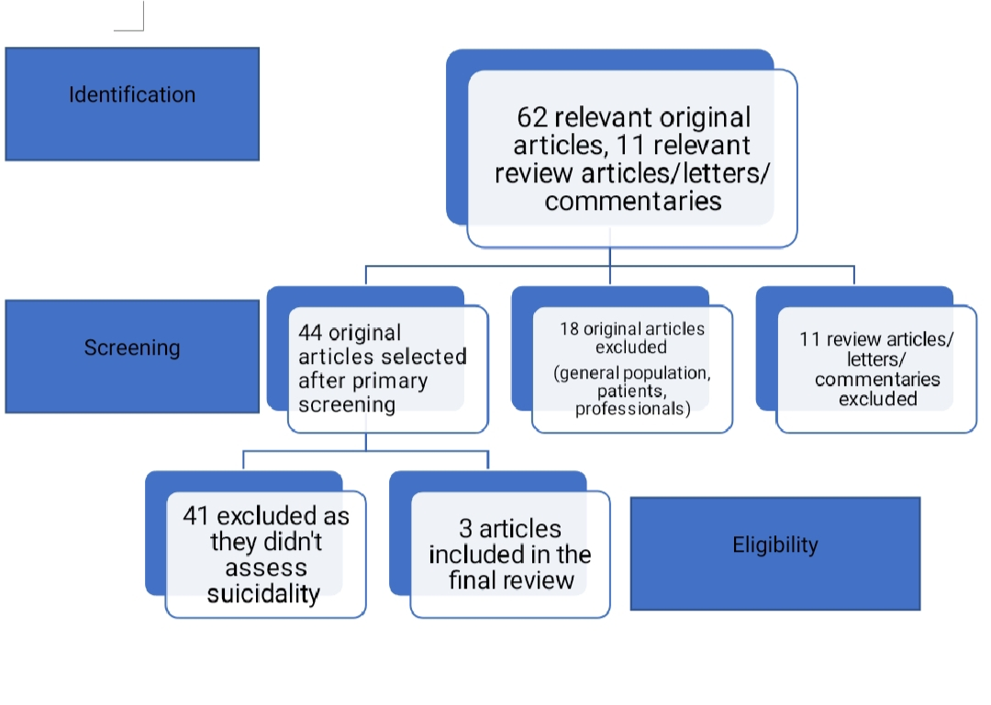
Received: 28-Oct-2022, Manuscript No. AMJ-22-3914; Editor assigned: 31-Oct-2022, PreQC No. AMJ-22-3914(PQ); Reviewed: 14-Nov-2022, QC No. AMJ-22-3914; Revised: 21-Nov-2022, Manuscript No. AMJ-22-3914(R); Published: 28-Nov-2022

